Special Guests
Name Assemblyman 38th District
Name Assemblyman 38th District
Name Bergen County Executive
Name Mayor, Oradell
Name

Name

We would like to acknowledge those who have supported and recognized our accomplishments:

(Insert names of people who sent certificates)

Thank you!
On behalf of the award recipients, we would like to thank all of the speakers and guests who attended the ceremony. The Girl Scouts is a leadership organization which builds courage, confidence and character. Thank you for acknowledging the contributions these girls have made to their communities.

ORADELL
Awards Ceremony
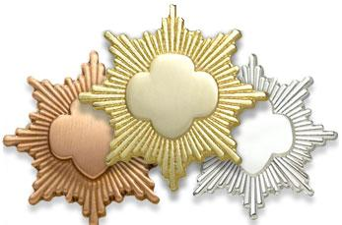

BOROUGH HALL
ORADELL, NEW JERSEY
DATE

Program
Opening Flag Ceremony: Troop XXXX

Welcome: name , Service Unit Manager

Bronze Award Presentations
This is the highest award that can be earned by a Girl Scout Junior. The Bronze Award enables each girl to develop more confidence, meet new people and have the kind of fun that happens when you work with other Girl Scouts to make a difference. Requires about 20 hours project time.
Troop 760
Leaders: name & name

Silver Award Presentations
This is the highest award that can be earned by a Girl Scout Cadette. The Silver Award enables each girl to utilize her skills and abilities to make an impact in her community. Requires about 40 hours project time.

Troop 760
Leader –
Name
Name

Troop 841
Leaders –
Name
Name

Gold Award Presentations

This is the highest award in Girl Scouting. The effort taken to earn this award expresses a special commitment to one’s self, community, world and future. Requires about 80 hours project time.

Troop 995
Leaders –

Today there are 2.7 million Girl Scouts of the USA – 2.1 million girl members and 800,000 adults working primarily as volunteers. Through it’s membership in the World Association of Girl Guides and Girl Scouts (WAGGGS), Girl Scouts of the USA is part of a worldwide family of 10 million girls in 146 countries.

